Internship report notes draft

RAG 101
RAG is a technology proposed by Patrick Lewis and colleagues at Meta in 2020, designed to augment the capabilities of language models by integrating a retrieval system with a language model. The retrieval system acts like a database, fetching relevant information to enhance the model's responses, while the language model integrates this information into contextually relevant answers. This system enables the creation of responses that are more diverse, accurate, and rich, compared to traditional models limited to their pre-existing knowledge base.
Embeddings and Vector Databases in RAG
The process begins with converting a user's query into embeddings or numeric representations, capturing the context and semantic meaning. This allows the AI model to efficiently process and compare the query against stored data. Vector databases store pre-processed information as embeddings, which the AI uses to search for and retrieve relevant information. This system ensures that responses are not only quick and precise but also richly informed by a vast array of data.
The Benefits of RAG
RAG offers several advantages, including enhanced accuracy through access to up-to-date information, dynamically updated information without the need for retraining, source attribution for transparency, and personalized interactions by understanding specific details from user queries. These benefits indicate a significant shift in AI interactions, making it a tool for informed, accurate, and contextually rich interactions across various fields.
Challenges and Limitations
Despite its advantages, RAG faces challenges such as the complexity of data retrieval, balancing relevance with reliability, computational resources and costs, and the need for ongoing development to keep the system effective and up-to-date. Addressing these challenges is crucial for the continued advancement and application of RAG technology.
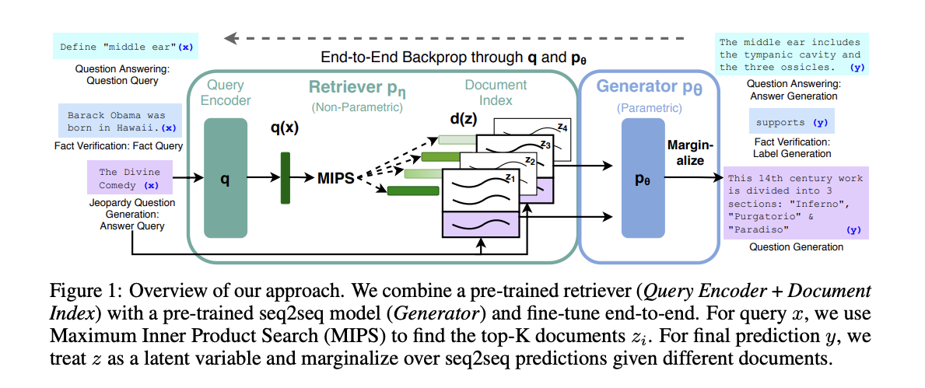

Figure 1: Overview of our approach
- The figure provides an overview of the approach used in the paper to combine a pre-trained retriever and a pre-trained seq2seq model for fine-tuning.
- The approach involves two main components: a retriever and a generator.
- The retriever consists of a Query Encoder and a Document Index, which are both pre-trained.
- The generator is a pre-trained seq2seq model.
- The approach aims to fine-tune these components together in an end-to-end manner.
Combining the pre-trained retriever and seq2seq model
- The approach combines the pre-trained retriever and seq2seq model to improve the performance of the model on knowledge-intensive tasks.
- The retriever is responsible for retrieving relevant documents from a dense vector index of Wikipedia based on a given query.
- The seq2seq model is responsible for generating the final prediction based on the retrieved documents.
Using Maximum Inner Product Search (MIPS) for document retrieval
- To retrieve the top-K documents relevant to a given query, the approach uses Maximum Inner Product Search (MIPS).
- MIPS is a technique that finds the documents with the highest inner product similarity to the query.
- By using MIPS, the approach can efficiently retrieve the most relevant documents for a given query.
Treating the retrieved documents as latent variables
- In the approach, the retrieved documents are treated as latent variables during the generation process.
- This means that the seq2seq model considers different combinations of retrieved documents when making predictions.
- By marginalizing over seq2seq predictions given different documents, the approach takes into account the uncertainty in the retrieved documents and generates more robust predictions.
- Overall, the approach combines a pre-trained retriever and a pre-trained seq2seq model, using MIPS for document retrieval and treating the retrieved documents as latent variables during the generation process. This approach aims to improve the performance of the model on knowledge-intensive tasks by leveraging both parametric and non-parametric memory. Pre-trained neural language models have limitations such as inability to expand or revise memory and producing "hallucinations".
- Hybrid models that combine parametric and non-parametric memories can address these issues.
- RAG (retrieval-augmented generation) combines a pre-trained seq2seq transformer as parametric memory and a dense vector index of Wikipedia as non-parametric memory.
- By incorporating non-parametric memory, hybrid models can access and manipulate external knowledge sources, enhancing their ability to generate accurate and diverse responses.

BM25, a king of sparse retrievers, which is just a cool extension of famous TF-IDF. What is interesting is that BM25 is a true dinosaur in ML/AI world, been here for decades and usually beating all those fancy shmancy transformers on general Information Retrieval benchmarks.
Nonetheless, BM25 offering a great advantage of allowing for exact term match, which both allows for great explainability and reliability. Though - NO FREE LUNCH - Term Vocabulary Mismatch Problem, or if say 'macdonalds meal' i also mean 'fast food'. Sparse vectors famously suffer from inability to retrieve simple synonyms and of course - context aware synonymous phrases. Transformers do.
And here comes the SPLADE. In short - at its simplest - BERT model with usual Masked Language Model head (predicting single words), aggregates distributions for the whole vocabulary calculated on predefined corpus, and creates a sparse vector based on these distributions. Then all the cool variations of sparse retrieval can be applied. Magic of combining worlds.
Anyways, Pinecone and Weaviate are two vector database providers which has SPLADE integrated and native

References to spalde
https://www.pinecone.io/learn/splade/
https://medium.com/@sowmiyajaganathan/hybrid-search-splade-sparse-encoder-neural-retrieval-models-d092e5f46913
https://europe.naverlabs.com/blog/splade-a-sparse-bi-encoder-bert-based-model-achieves-effective-and-efficient-first-stage-ranking/
sparse vector
https://qdrant.tech/articles/sparse-vectors/

RAG Architecture can have many Components

Issues and components to consider:

Chunking and vectorization
Hierarchical indices
Hypothetical questions and HyDE
Context enrichment
Fusion retrieval or hybrid search
Reranking and ﬁltering
Query transformations
Response synthesis
Encoder and LLM ﬁne-tuning

Explaination on splade
https://www.pinecone.io/learn/splade/

graphs explaination
F1-Score Bar Chart
In the F1-Score graph, each bar represents the F1-Score for a specific article topic such as "inflammation", "neoplasms", or "embolism". The F1-Score combines precision and recall into a single measure. For example, if the bar for "neoplasms" is very high, it suggests that when the model predicts a question is relevant to "neoplasms", it is often correct (precision), and it also does a good job of identifying most relevant questions for "neoplasms" (recall).

Precision Bar Chart
In the Precision graph, consider a bar representing "atherosclerosis". If this bar is tall, it means that when the model predicts a question pertains to "atherosclerosis", that prediction is usually accurate. However, if the bar is short, it indicates that the model often incorrectly labels questions as related to "atherosclerosis" when they are not.

Recall Bar Chart
In the Recall graph, look at the bar for "acute inflammation". If this bar is high, it means the model is successfully identifying most questions that are truly about "acute inflammation". If the bar is low, it means there are questions about "acute inflammation" that the model is failing to recognize.

Confusion Matrix Heatmap
The Confusion Matrix provides a detailed breakdown of the model's predictions. Each cell shows how many questions belonging to a particular article (row) were predicted to be about another article (column).
For example, if we look at the cell in the heatmap where the row for "simplemed#basics-of-pathology" intersects with the column for "simplemed#basics-of-pathology", and the cell contains the number 7, this means that there were 7 questions correctly identified as belonging to "simplemed#basics-of-pathology".
However, if you look at the row for "simplemed#lymphatic-system" and follow it across to the column for "simplemed#haemostasis-and-clotting" and see a number there, that indicates the number of times the model incorrectly predicted questions about the "lymphatic system" as being about "haemostasis-and-clotting". Ideally, you would want all of the high numbers to be along the diagonal (meaning correct classifications), and the rest of the heatmap to be zeroes or very low numbers (indicating few misclassifications).
These visualizations provide insights into the model's performance on a per-article basis and can help identify which topics the model handles well and which topics might need further training data or model tuning.

Results explained
F1-Score Bar Chart
From the F1-Score bar chart, it appears that the model performs variably across different articles. Some articles, like those related to "neoplasms" or "cellular adaptations," have higher F1 scores, suggesting that the model has a balanced performance in terms of precision and recall for these topics. However, other articles, such as those on "lymphatic system" or "thrombosis and embolism," have lower F1 scores, indicating that the model's performance is less effective for these topics. This could be due to various factors such as fewer training examples for these classes, more complex content that is harder to classify correctly, or similarities with other topics that cause confusion.

Precision Bar Chart
The Precision bar chart reveals that for most articles, the model has a reasonably high precision, with several topics achieving scores close to or above 0.8. This suggests that when the model predicts a question as belonging to most of these topics, it is likely to be correct. However, the precision is notably lower for a couple of topics, which could mean that the model is producing more false positives for these articles, labeling non-relevant questions as relevant.

Recall Bar Chart
In the Recall bar chart, the model's performance seems more inconsistent. Some articles have high recall, meaning the model is good at capturing most relevant questions for those articles. In contrast, other articles, particularly "neoplasia" related topics, show lower recall. This indicates that the model is missing a significant number of relevant questions for these articles, which could be a concern if these topics are important to users.

Confusion Matrix Heatmap
The Confusion Matrix heatmap provides a detailed view of the model's predictions. Most correct predictions are concentrated along the diagonal, showing the model is correctly classifying questions for several articles. However, there are some off-diagonal numbers which represent misclassifications. For instance, there are confusions between "lymphatic system" and "haemostasis-and-clotting", suggesting that the model is confusing these topics with each other. This could be addressed by providing the model with more distinguishing training data or refining the model's features to better differentiate between these topics.

Overall Comments
The model seems to have areas of strength and weakness. High precision across most topics indicates the model is useful in confidently identifying relevant questions for certain articles. However, the variability in recall suggests that it is not as effective in consistently

Used for presentation
https://www.youtube.com/watch?v=wd7TZ4w1mSw&list=RDCMUCC-lyoTfSrcJzA1ab3APAgw&index=6

The development of the Retrieval-Augmented Generation (RAG) system in the field of pathology marks significant progress towards enhancing the capabilities of Large Language Models (LLMs) to provide accurate and relevant data. The integration of a smart retrieval system with language model abilities shows promising results in delivering trustworthy responses in pathology. The evaluation phase of the system achieved an impressive 80\% accuracy in identifying questions, indicating RAG's potential to surpass existing LLM limitations.

Looking ahead, it is crucial to further enhance the RAG system to address potential risks and challenges, such as ensuring efficient data processing and resource utilization. Future enhancements will focus on refining the hybrid search approach, optimizing knowledge base,doing reranking of the documents and post-processing the generated text for better answer generation quality and acquiring specialized datasets to strengthen the system. With respect to making this Question n- Answering system into a live chatbot varient which keeping the history (via agents), and also generate the follow-up questions for the user based on the response from the previous question which can enhance the user-experience.Continuous testing and evaluation will improve operational efficiency and accuracy of pathological data delivery.

By excelling in retrieval- and generational-components, RAG has the potential to become the standard in Question-Answering/Context Summeriser in specialized fields. The testing results from this project pave the way for advancements in natural language processing applications, particularly in medical and other specialized fields. As language processing technology advances, the possibilities are endless.

While the costs associated with using the openAI API were relatively low (0.61 \euro) for this project, a production system would require a more extensive dataset to handle a wide range of examination questions. Therefore, considering hosting custom chatbots may be a viable option to meet these needs.

The key question remains: Can fine-tuning using a hybrid approach be successful? Fine-tuning the retrieval component involves optimizing search strategies to identify relevant documents effectively. Adjusting keyword search weightings and semantic search criteria based on specific domain requirements are crucial aspects of fine-tuning. Additionally, modulating the temperature percentage of the retrievers (bm25 and Faiss) in a hybrid search can enhance search results significantly.

